**Antique Gold Small Star Convex Mirror**

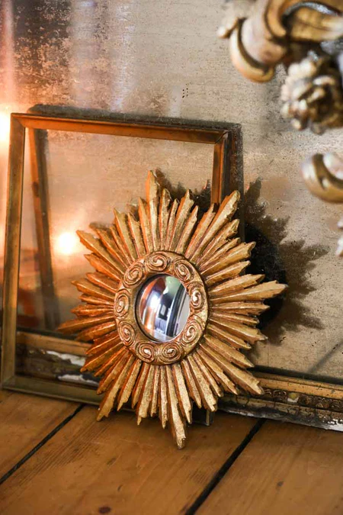The Antique Gold Small Star Convex Mirror is a dazzling piece that blends celestial charm with vintage elegance. Featuring a convex mirror surrounded by a radiant star-shaped frame, this decorative mirror creates a striking focal point in any space. The antique gold finish adds warmth and sophistication, enhancing its timeless appeal. Its small size makes it perfect for compact areas like entryways, bedrooms, or as part of a gallery wall. With its unique design and eye-catching details, this mirror not only serves as a functional reflection but also as an exquisite decorative accent that brings a touch of luxury to your home.